SWAMS: Smart Water Access Monitoring System
Final Project Report
_____________________________________________________
Table of Contents
1. Introduction
2. Problem Statement
3. Sustainable Development Goal (SDG) Alignment
4. Proposed Solution
5. Software Development Life Cycle (SDLC)
6. System Requirements
7. System Architecture Diagram
8. UML Diagrams
9. Figma Prototype Screens
10. GitHub Integration
11. Project Planning - Gantt Chart
12. Software License
13. Conclusion
14. References

1. Introduction
SWAMS (Smart Water Access Monitoring System) is a Digital Public Good developed to improve access, monitoring, and management of water resources. Many communities experience challenges such as unreliable water supply, delayed reporting of faults, and limited information about available water sources. These challenges can affect daily activities and make it difficult for water managers to provide effective services.
SWAMS provides a digital platform that allows users to view water availability, report problems, and receive updates. The system also allows administrators to monitor water access points and manage information efficiently. By using digital technologies, SWAMS improves communication between communities and service providers while supporting better decision-making. The project applies software engineering principles through proper planning, system analysis, design, development, and documentation.
2. Problem Statement
Many public water access points are managed manually, making it difficult to know whether water is available or whether a system requires maintenance. Users may travel long distances only to find that a water source is unavailable. Water managers may also struggle to identify problems quickly because there is no centralized monitoring system.
These challenges lead to poor service delivery, wasted resources, and reduced reliability of water services. SWAMS solves this problem by creating a smart monitoring system that collects and displays water information. The system enables users to access updates and report issues while allowing administrators to monitor water points and respond faster.
3. Sustainable Development Goal (SDG) Alignment
SWAMS aligns with Sustainable Development Goal 6: Clean Water and Sanitation. The goal focuses on improving access to safe water and ensuring sustainable management of water resources.
The system supports this goal by:
- Providing information about water availability.
- Improving monitoring processes.
- Helping communities manage water resources effectively.
By reducing delays in identifying water problems, SWAMS contributes to better maintenance and improved access to clean water. The project demonstrates how technology can support public services and encourage sustainable resource management.
4. Proposed Solution
The proposed solution is SWAMS, a smart platform that connects community users, administrators, and monitoring systems.
- Community Users: Can access water availability information, view water points, and report problems through the platform.
- Administrators: Can manage water stations, monitor reports, and review collected data.
The system is designed to improve efficiency, transparency, and communication. Future improvements may include sensor integration for automatic water level monitoring. SWAMS provides a scalable solution that can support more communities and water points over time.
5. Software Development Life Cycle (SDLC)
Selected Model: Agile Methodology
- Requirements Gathering: Identify user needs and water management challenges.
- Analysis: Study system functions, users, and data requirements.
- Design: Create architecture, database structure, and interface designs.
- Development: Build the software components.
- Testing: Check functionality, performance, and reliability.
- Deployment and Maintenance: Release the system and improve it through updates.
6. System Requirements
Functional Requirements:
- User registration and login
- View water availability
- Report water problems
- Manage water points
- Generate reports
Non-Functional Requirements:
- Security
- Reliability
- Usability
- Performance
- Scalability

7. System Architecture Diagram
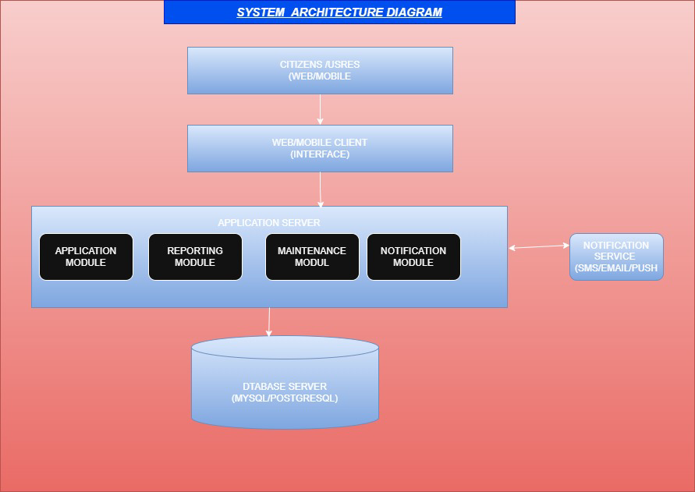
8. UML Diagrams
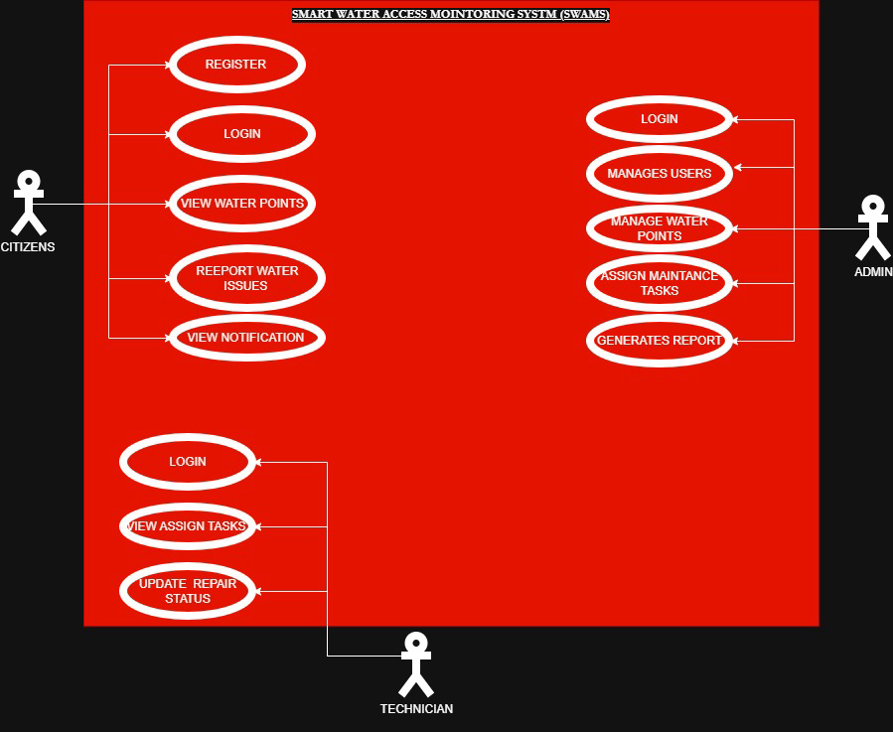
Use Case Diagram

Class Diagram
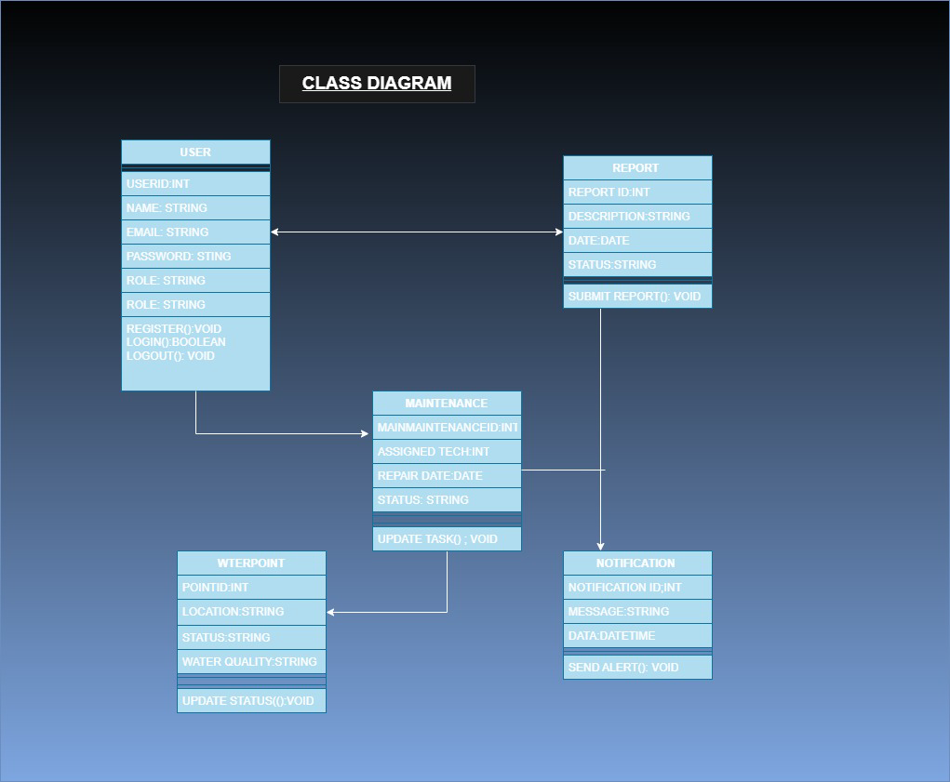

Activity Diagram

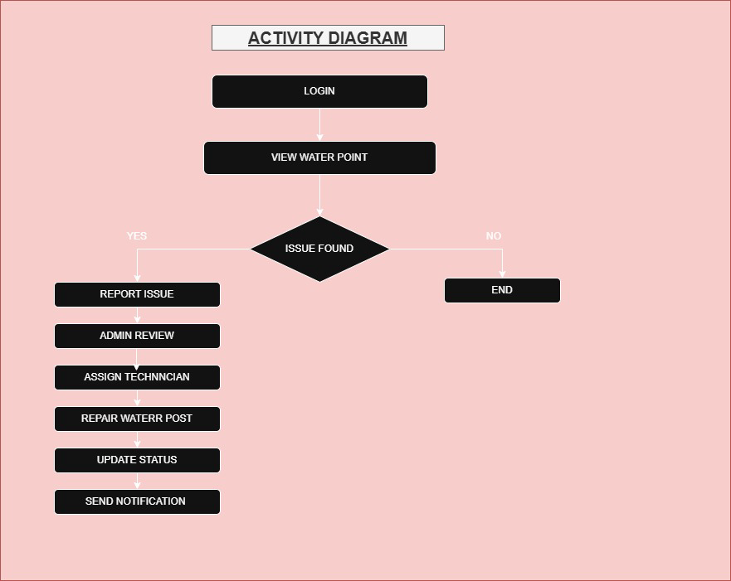

9. Figma Prototype Screens
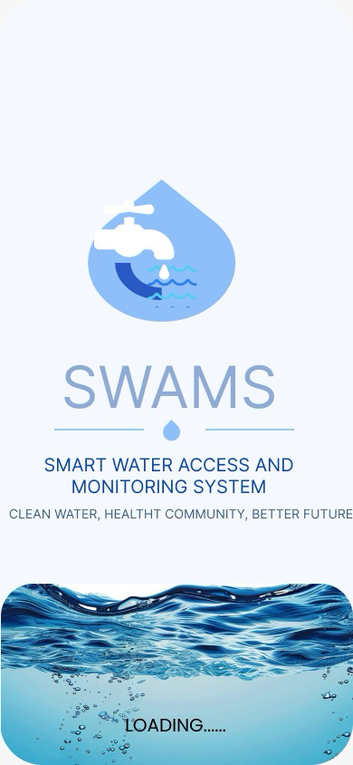
Screen 1

Screen 2
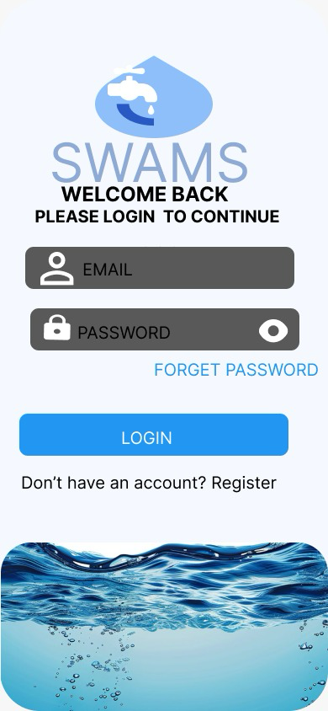

Screen 3

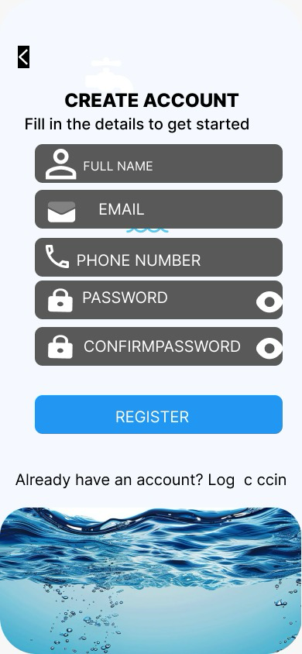

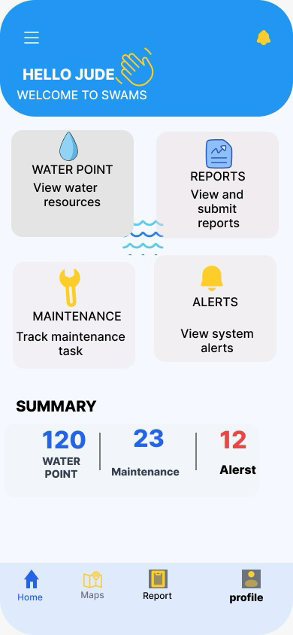
Screen 4

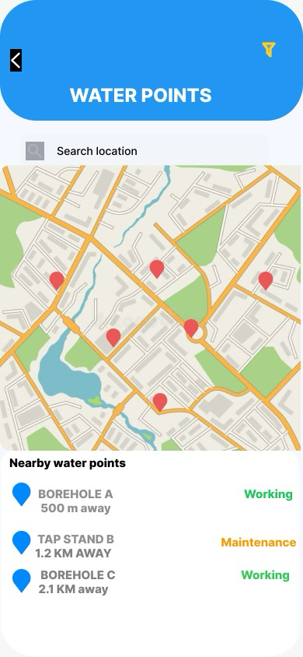
Screen 5

Screen 6
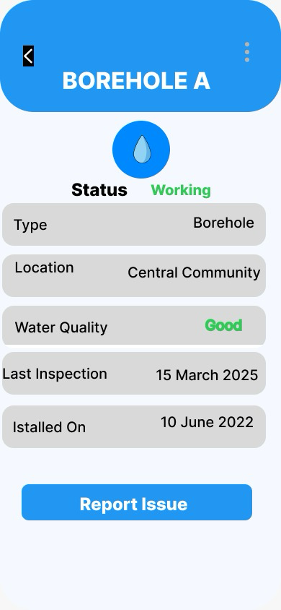

Screen 7
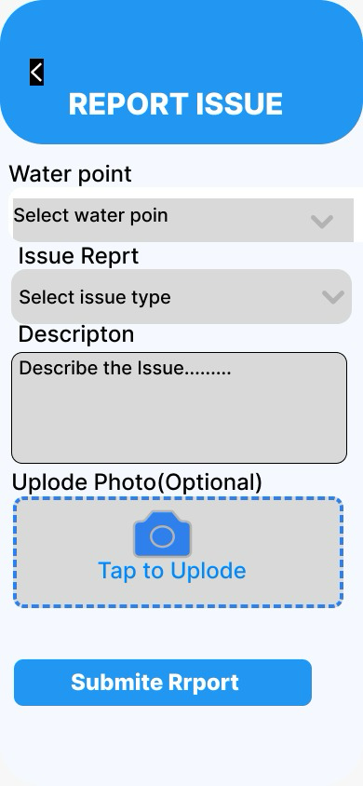

Screen 8
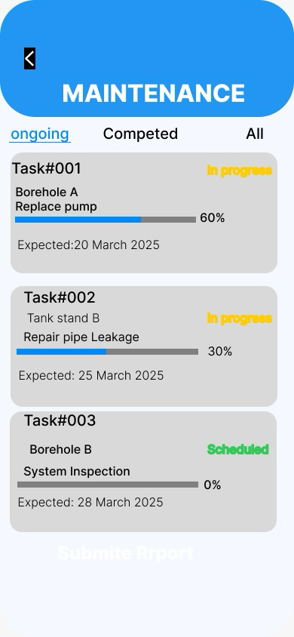

Screen 9

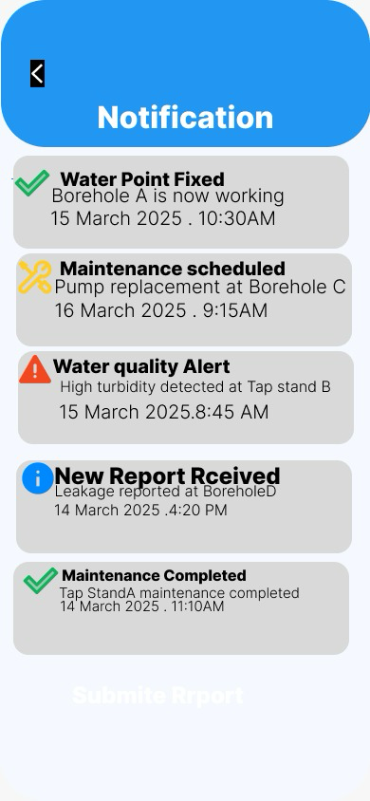

Screen 10

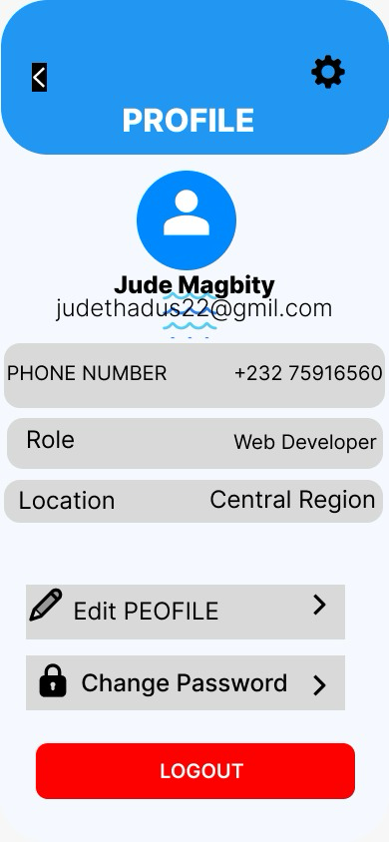

Screen 11
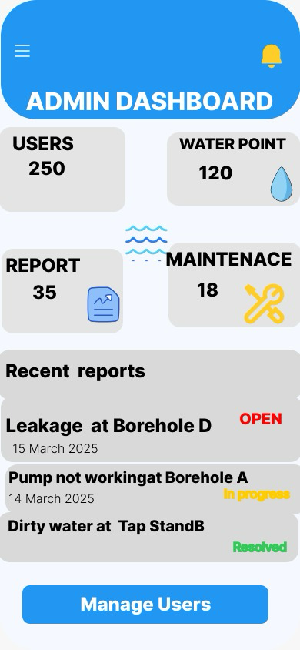

11. Project Planning - Gantt Chart
SWAMS Gantt Chart
Task | Week 1 | Week 2 | Week 3 | Week 4 | Week 5
Research | ✓
Requirements | ✓ | ✓
Design |  | ✓ | ✓
Prototype |  |  | ✓ | ✓
Testing |  |  |  | ✓ | ✓
Documentation |  |  |  | ✓ | ✓

12. Software License
Selected License: MIT License
The MIT License is selected because it allows users to use, modify, and share the software. It supports collaboration and encourages improvements while keeping the project open for public benefit.
13. Conclusion
SWAMS provides a practical digital solution for improving water access monitoring and management. The system addresses challenges related to unreliable water information, delayed maintenance, and inefficient communication.
By allowing users and administrators to access important water data, SWAMS improves decision-making and supports better public service delivery. The project demonstrates the importance of software engineering practices in creating solutions for real-world problems. Through SDLC planning, system design, prototyping, and documentation, SWAMS contributes to sustainable water management and supports SDG 6.
14. References
1. Ian Sommerville - Software Engineering.
2. United Nations Sustainable Development Goals.
3. Figma Documentation.
4. GitHub Documentation.
5. Smart Water Management Resources.

